**Cloud Computing**

Session 8 : Relational Database Services

Assignment 1: Working with RDS

* Creating a Webserver in EC2 to connect to RDS

We can access a MySql database in RDS through a public webserver running on EC2.

1. Create a VPC Security Group for a public webserver from the VPC Dashboard.
2. Determine your public IP Address with the amazon service at <http://checkip.amazonaws.com>.
3. Add an inbound rule to the security group with access type as SSH and source as your public IP.
4. Add one more rule with access type as HTTP and source as Anywhere ( 0.0.0.0/0 )
5. Launch an EC2 Instance ( Ububtu Server 14.04 LTS ) with the newly created security group.
6. Login to the Ubuntu instance with the public DNS and update the instance with

sudo apt-get update command.

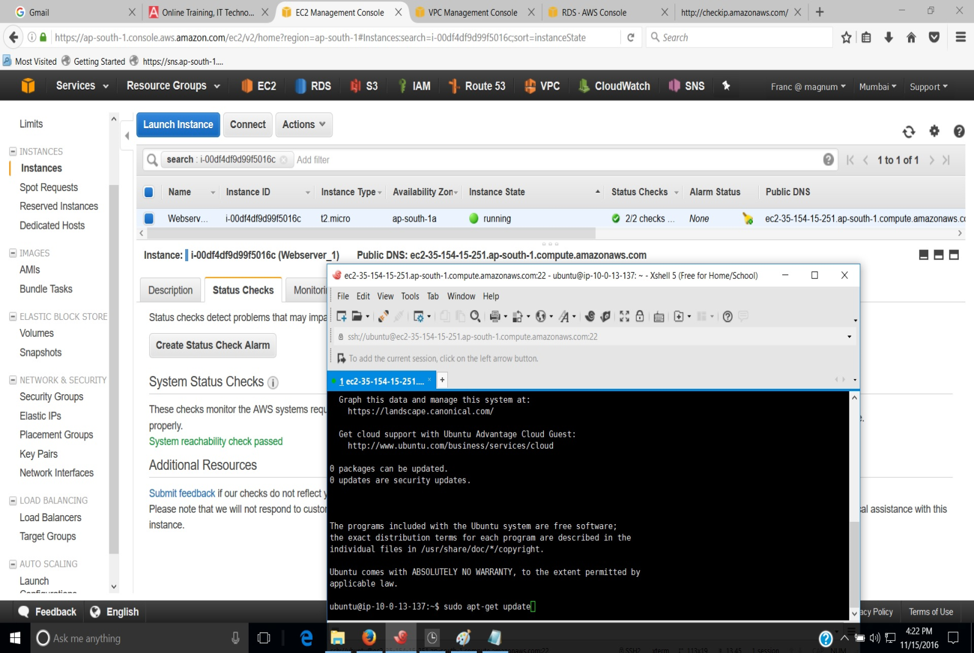

1. Upgrade the packages in Ubuntu instance with the command sudo apt-get -y upgrade.

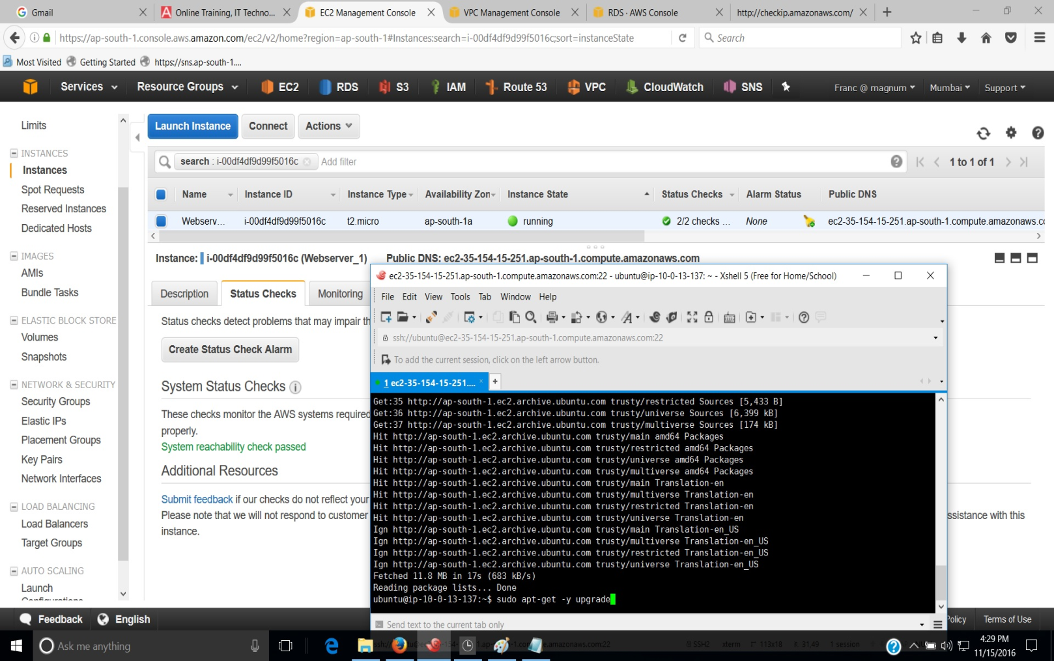

1. Install mysql-client in the EC2 instance to establish connection with RDS.

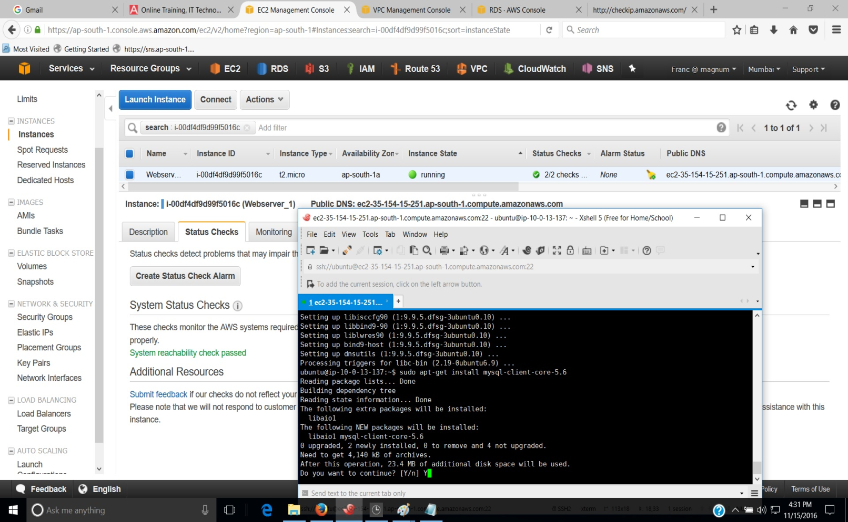

* Creating a Webserver in EC2 to connect to RDS

1. Open the RDS console and select the region in which you need to create DB Instance.
2. Select Instances tab on the Navigation pane and click on Launch DB Instance.

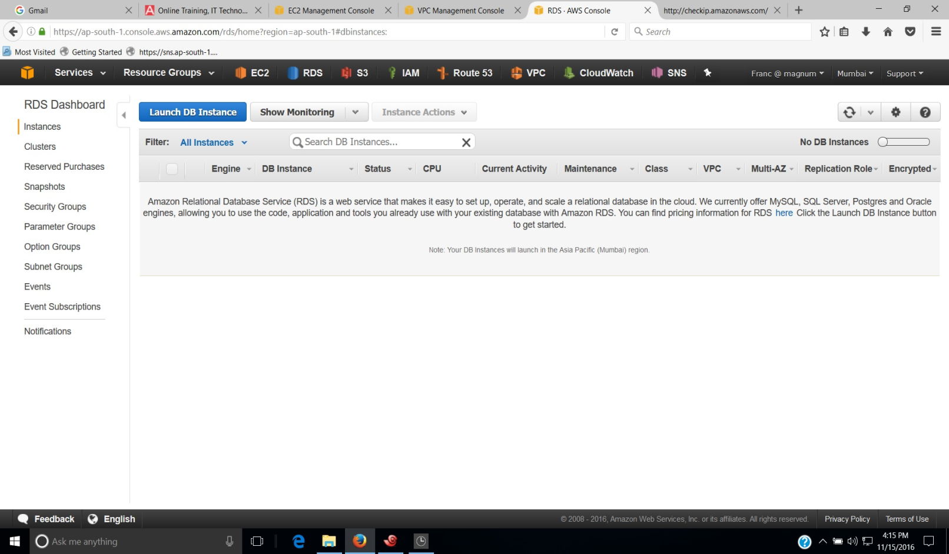

1. Choose the type of DB Engine ( MySql ) from the tabs and click on Select button.

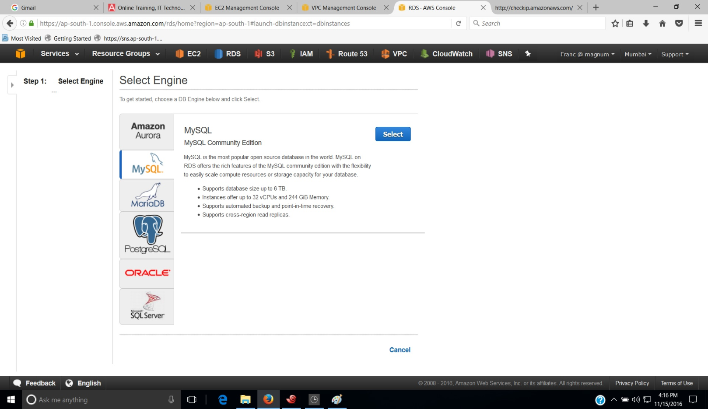

1. Select the purpose of the DB Instance ( Dev/Test ) and click on Next Step.

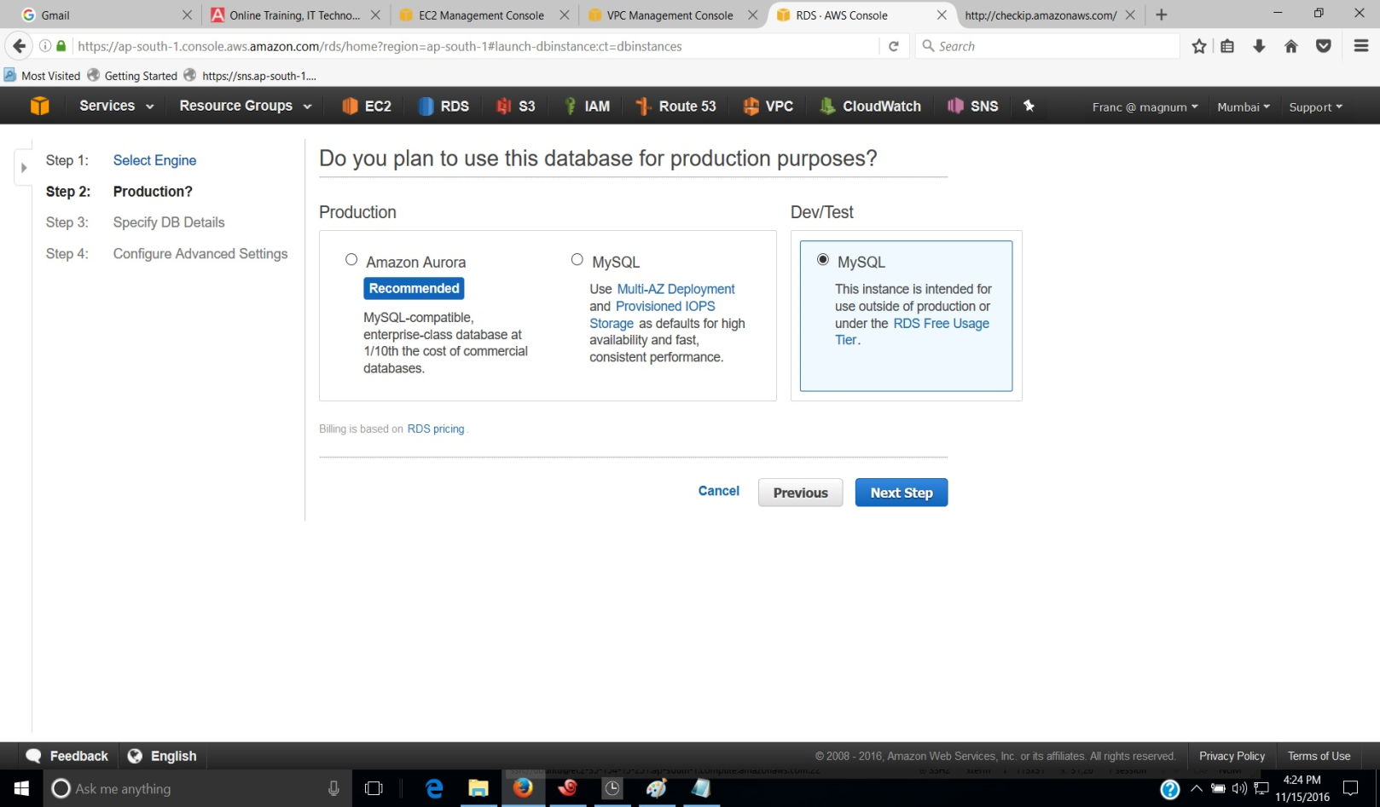

1. Provide the DB Instance specifications on the Specify DB Details page. We can select the license model, version of DB Engine, type of instance and storage types.

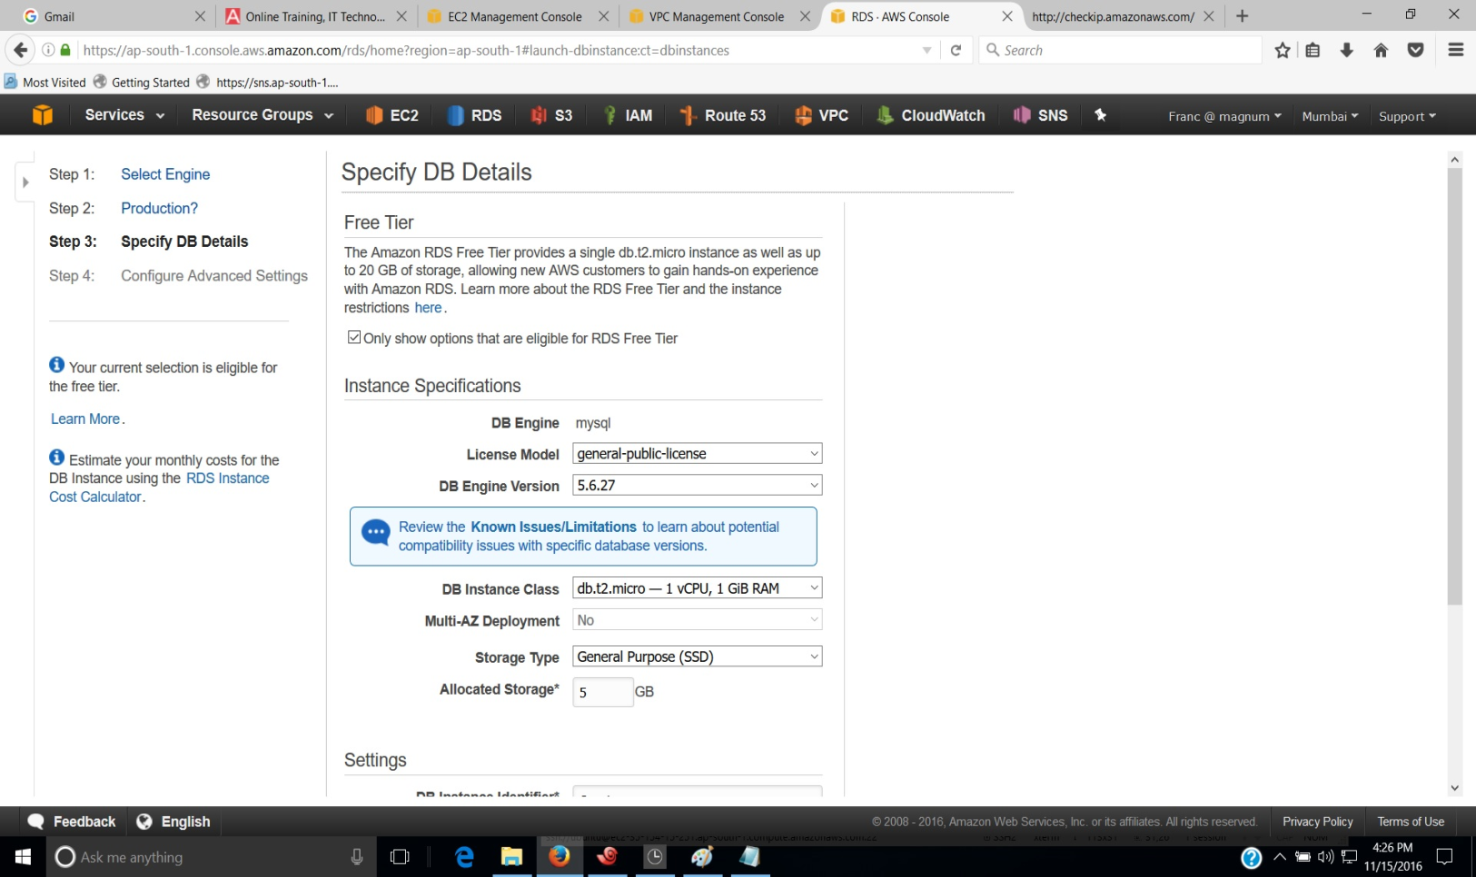

1. Further we can specify options such as DB Instance Identifier, Master Username and password.

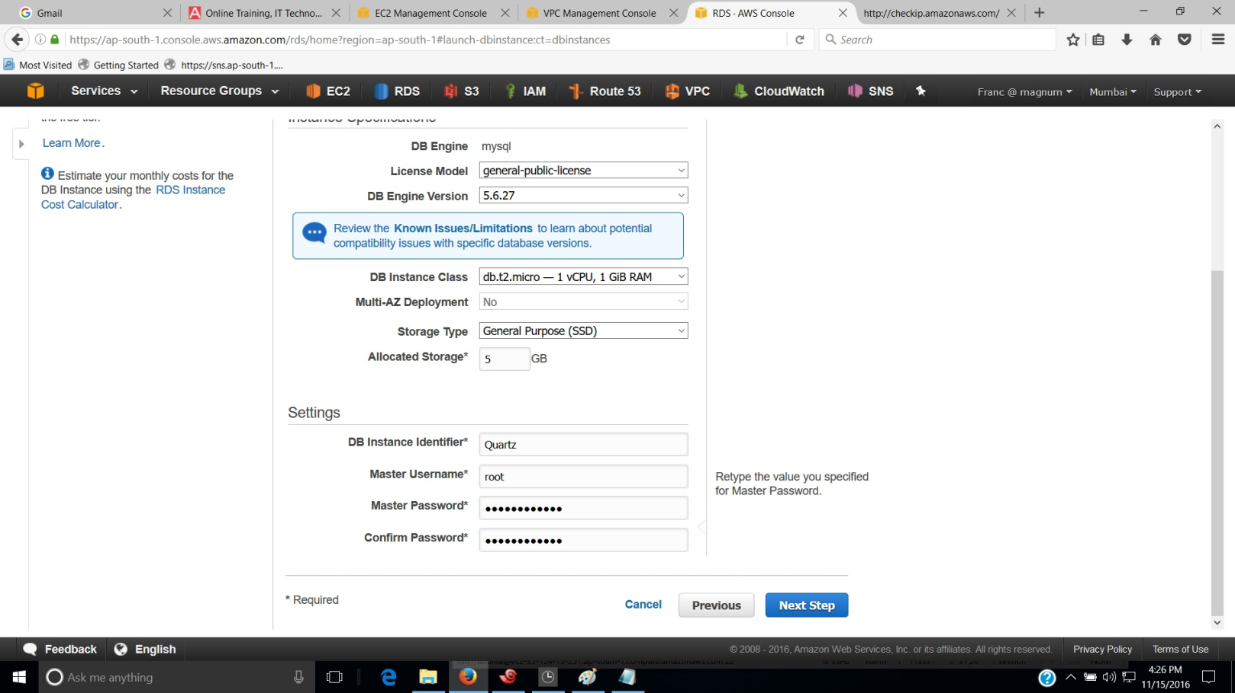

1. Advanced Settings of the DB Instance can be specified by selecting VPC, Subnet group, Public accessibility, Availability zone etc. We can also select or create security group and provide a database name.

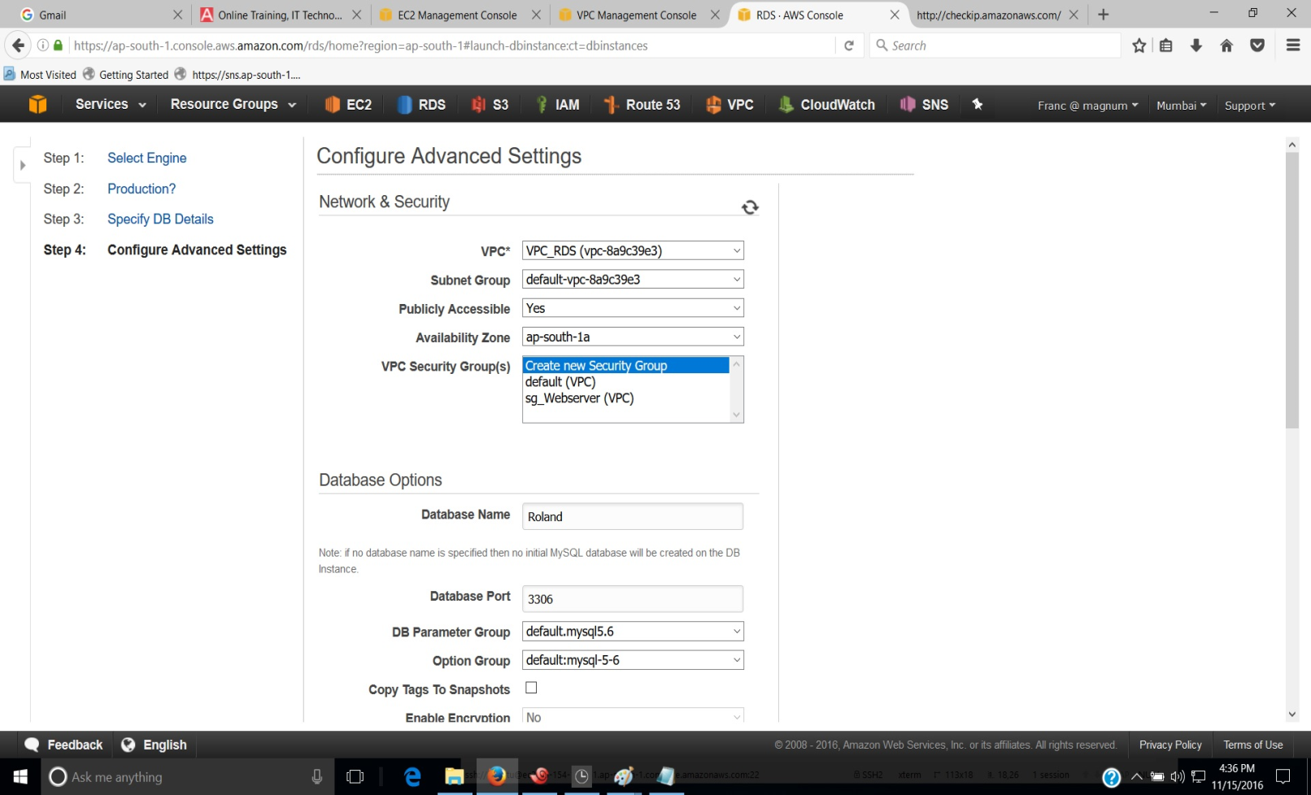

1. Further we can configure options such as Snapshots, Encryption, Backup Retention period, Enhanced monitoring and maintenance window. Finally click on Launch DB Instance to create DB Instance.

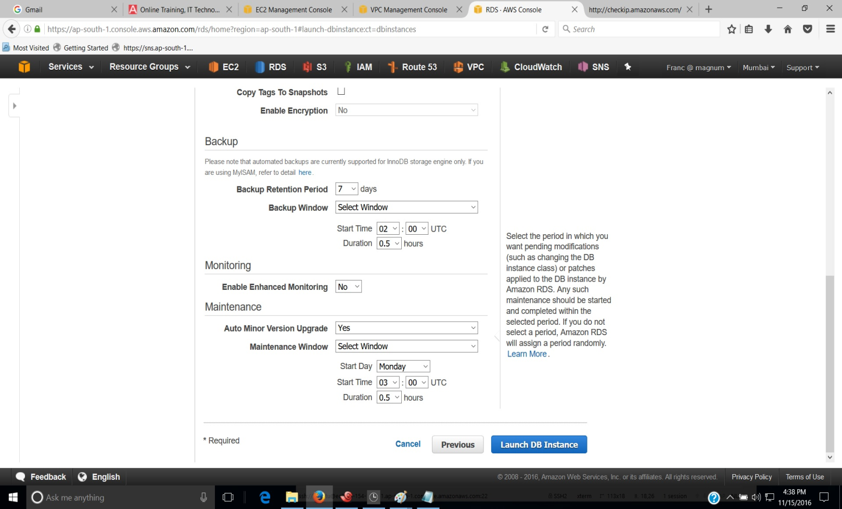

1. Click on View your DB Instances to see RDS instance details.

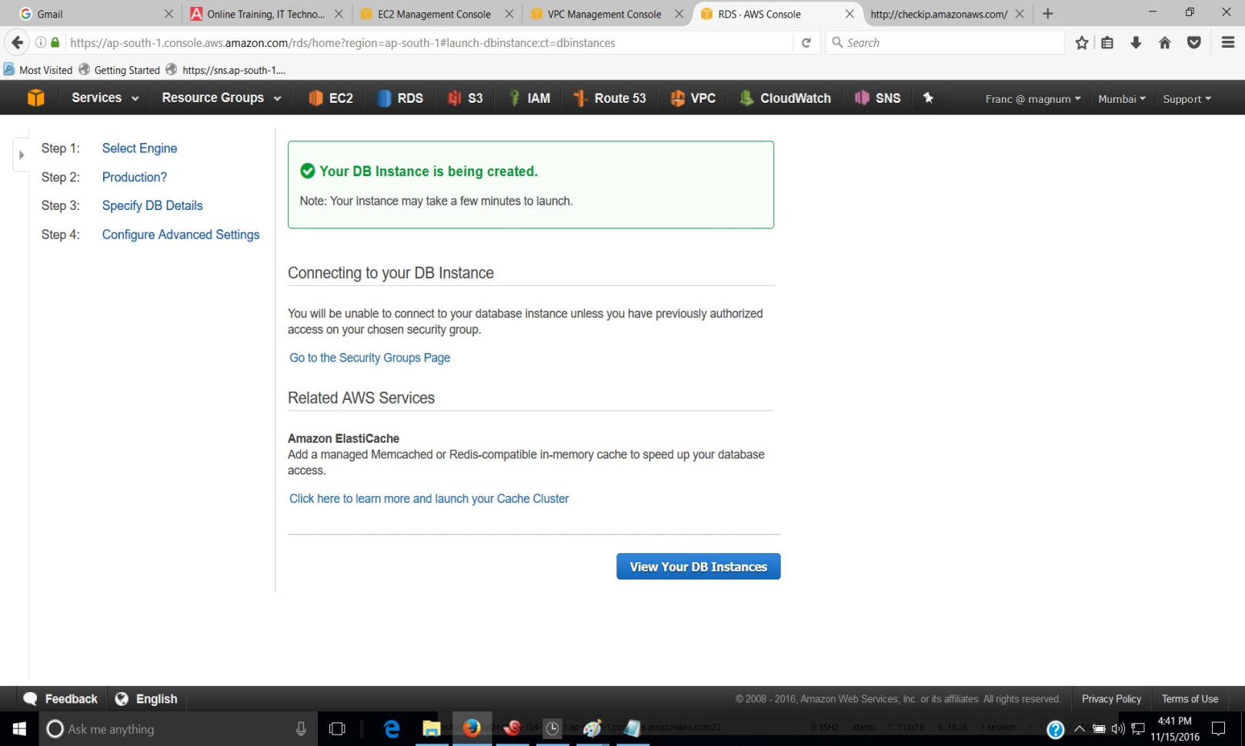

1. If the DB Instance is showing the status as available on the RDS console, it is ready for use.

We need to configure the security group of the RDS to connect to the DB Instance.

1. Select the DB Instance and click on the middle tab. The Configuration details of the DB Instance will be shown. Click on the name of the security group under security and network section.

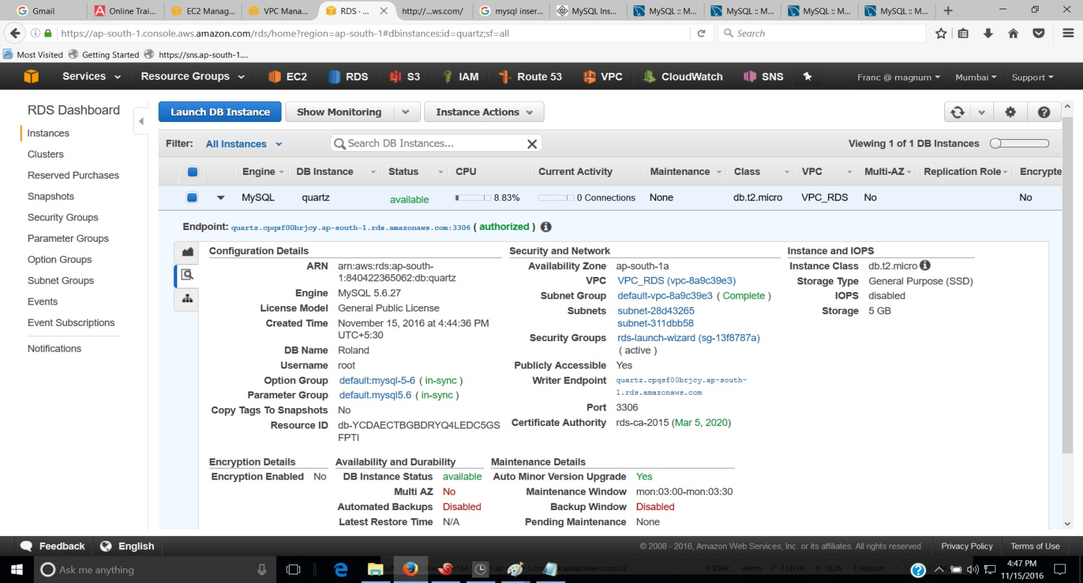

A new window will open up which shows the security group of the RDS.

1. Select the Inbound Rule tab and click on Edit to change the source of the Rule.
2. Select Custom from the combo box under Source and type the name of the security group with which EC2 Instance is launched, in the text box. Click on save to set the new access settings.

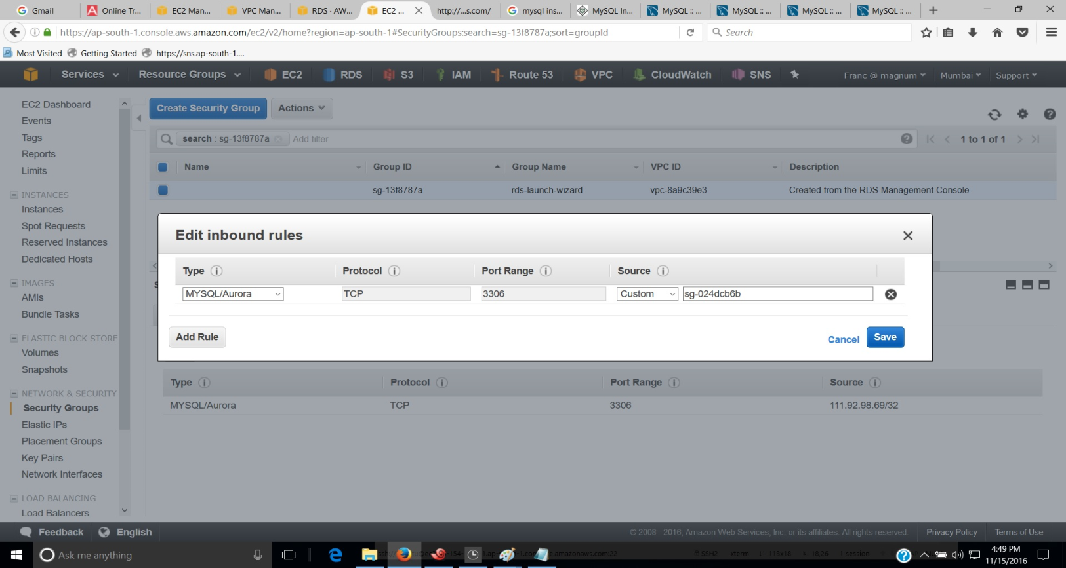

1. Connect to the DB Instance with the mysql command by providing endpoint URL and Master username and password of the of the DB Instance.
2. Once the connection is established give show databases command to list available databases.

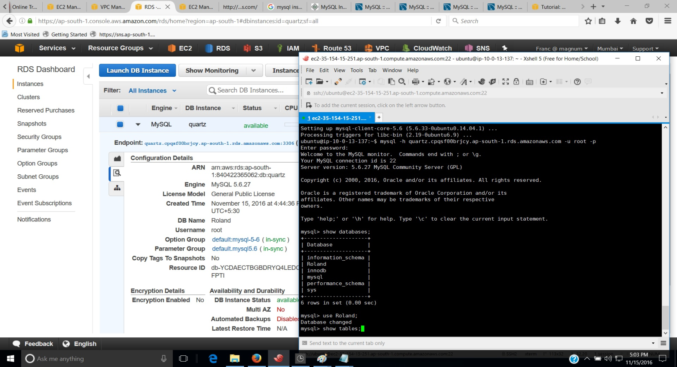

1. Exit from DB Instance by giving exit command to download the backup file of the world database.

Database migration can be done by downloading the backup file into the Webserver. ( EC2 instance)

1. First create a directory with mkdir command and then change into the new directory.
2. Provide wget command with the location of the database backup file to download it.

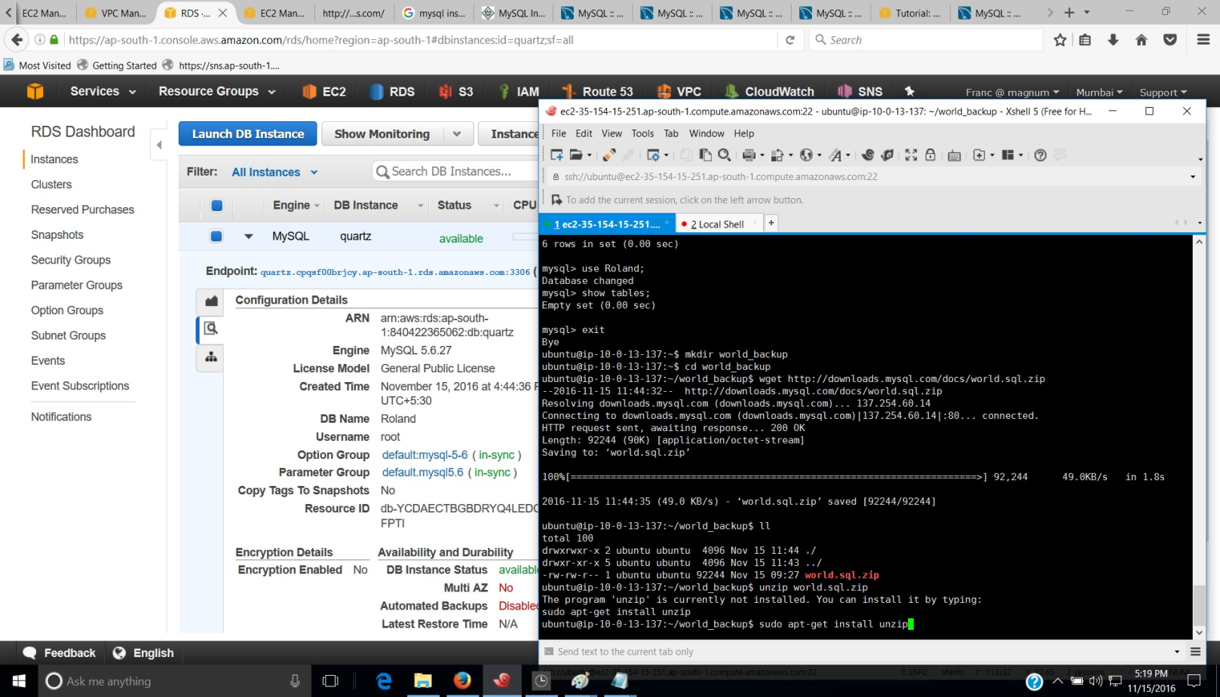

1. Give unzip command to unzip the database-backup file.
2. Connect again to the DB Instance with the mysql command by providing endpoint URL.
3. Provide command to migrate database from local to the RDS Instance.

source <filename>.sql;

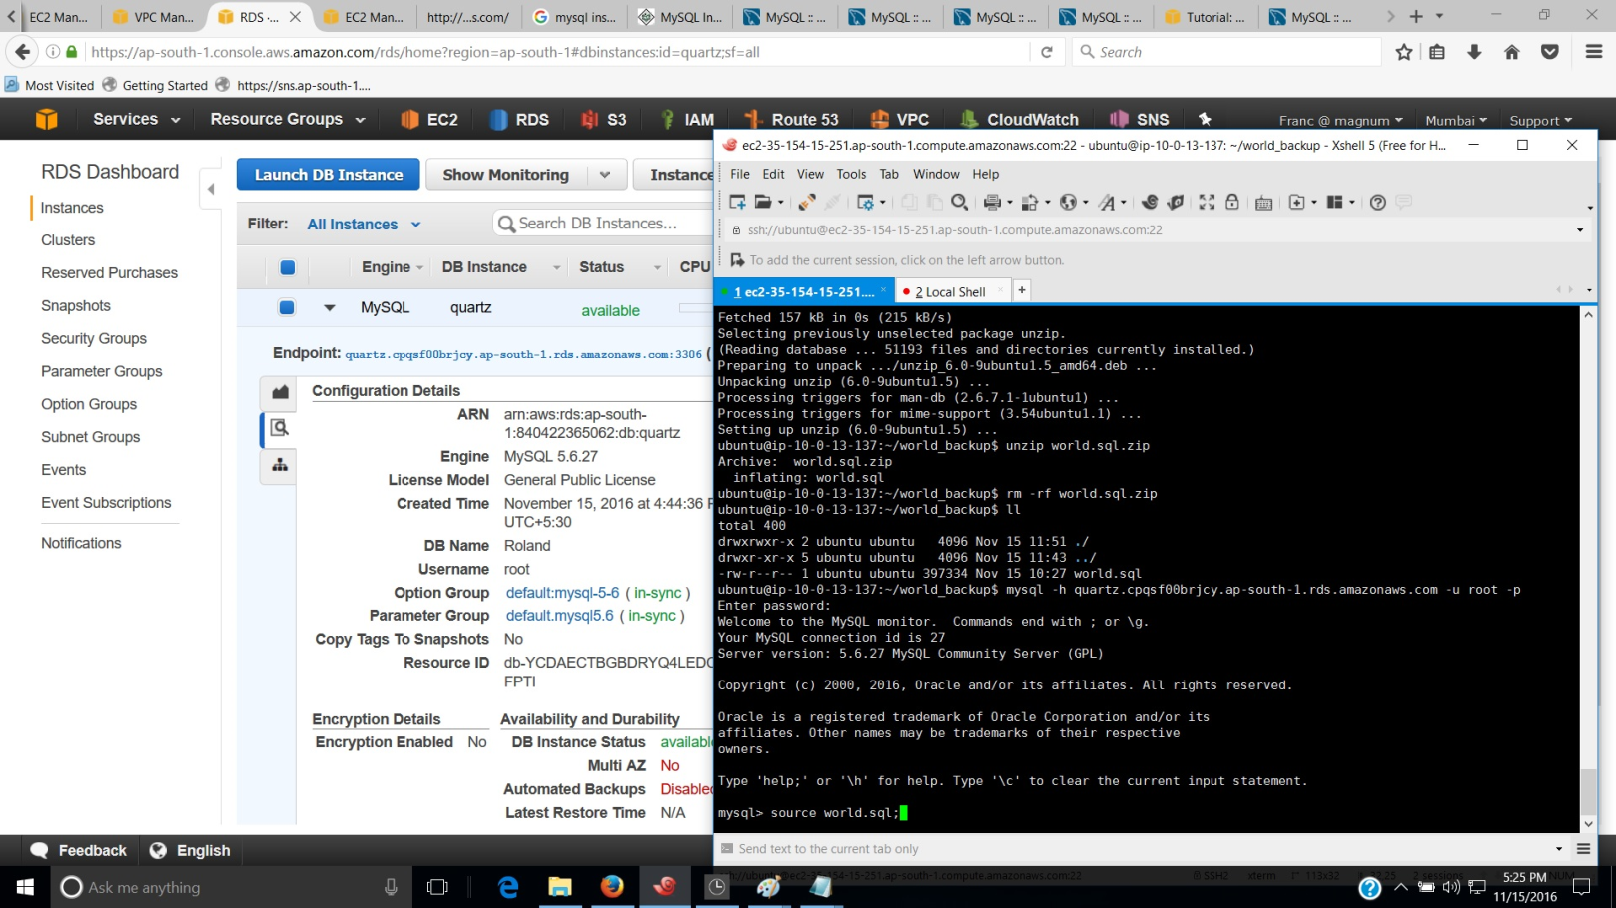

1. Once the Database migration is complete list the databases with show databases command.

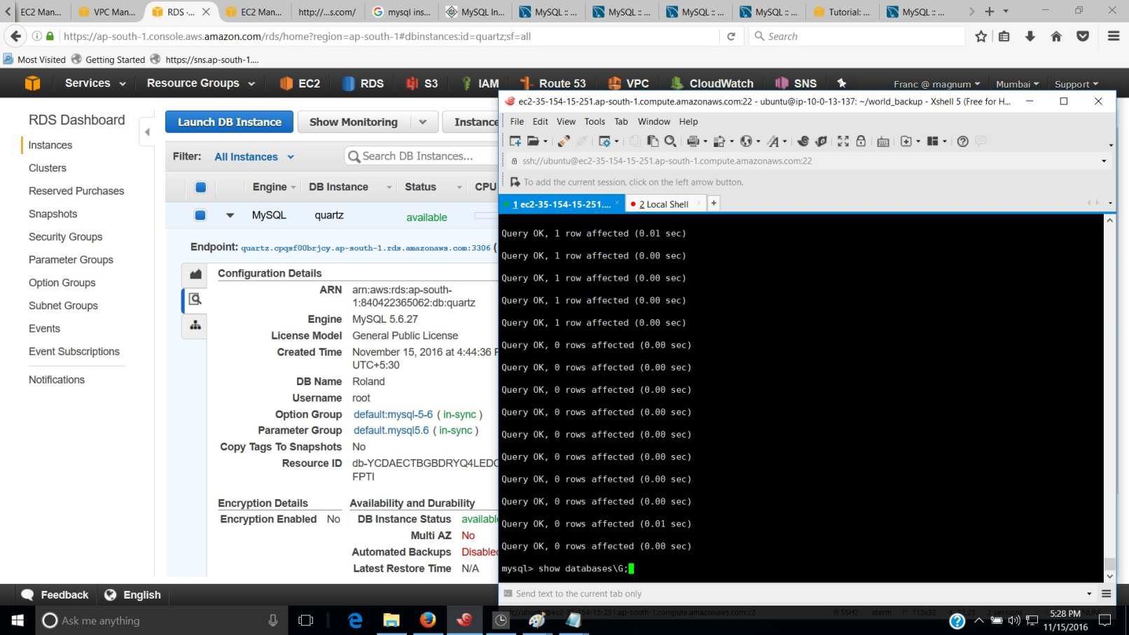

1. Change to the migrated database with use command. We can list the tables in the new database with show tables command.

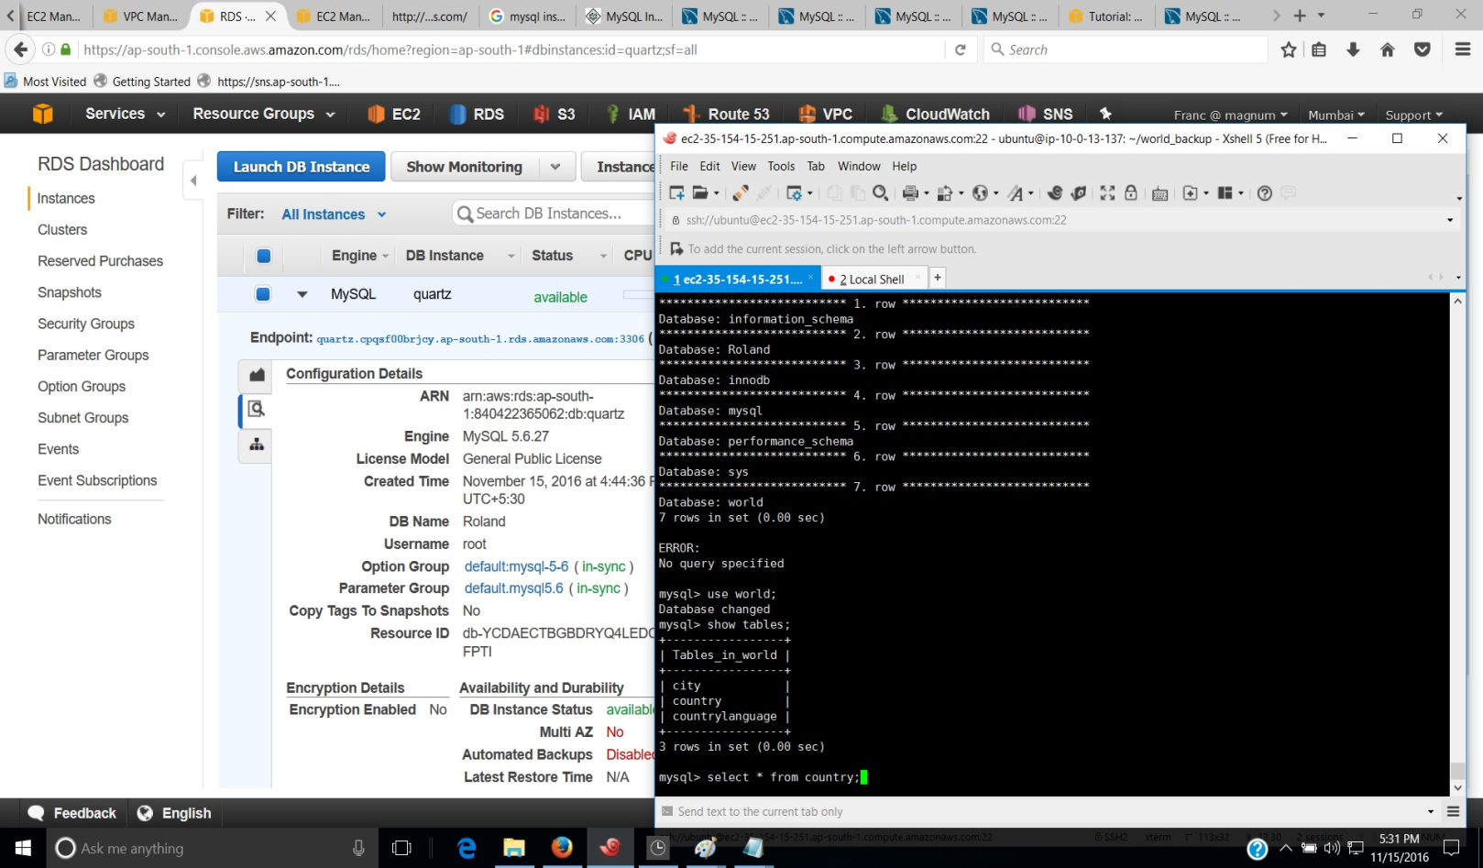

1. Create a new database in DB instance with create database command.
2. Change into the new database and create a table and insert several rows.

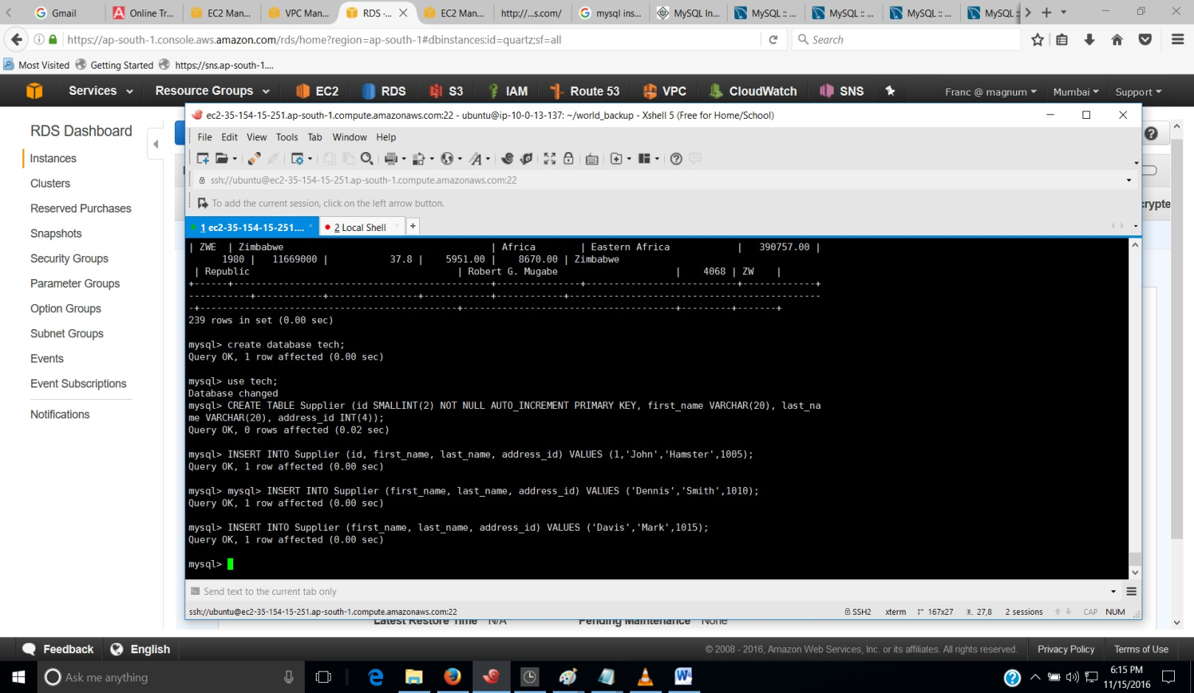

1. Exit from the Db Instance to backup the database with mysqldump command.

Syntax of the command is as follows:-

mysqldump -h (Endpoint URL of DBInstance) -u username -p database_to_backup > backupname.sql

1. Once sql script file is created ( backup-file ) give ‘ll’ to list its details.

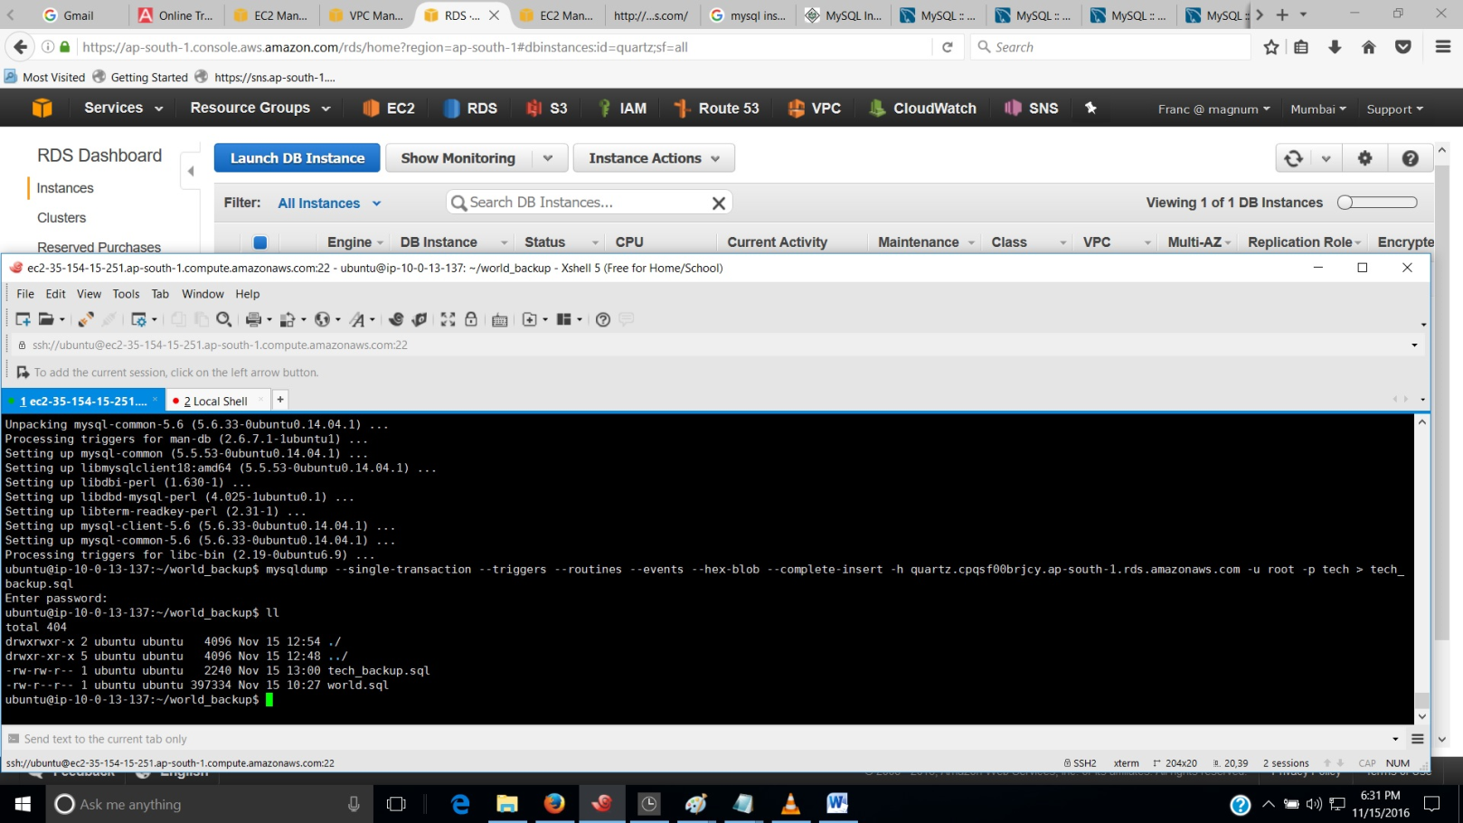

1. Connect to DB Instance again and drop the table created earlier in the new database.
2. Give the source command to restore the database.

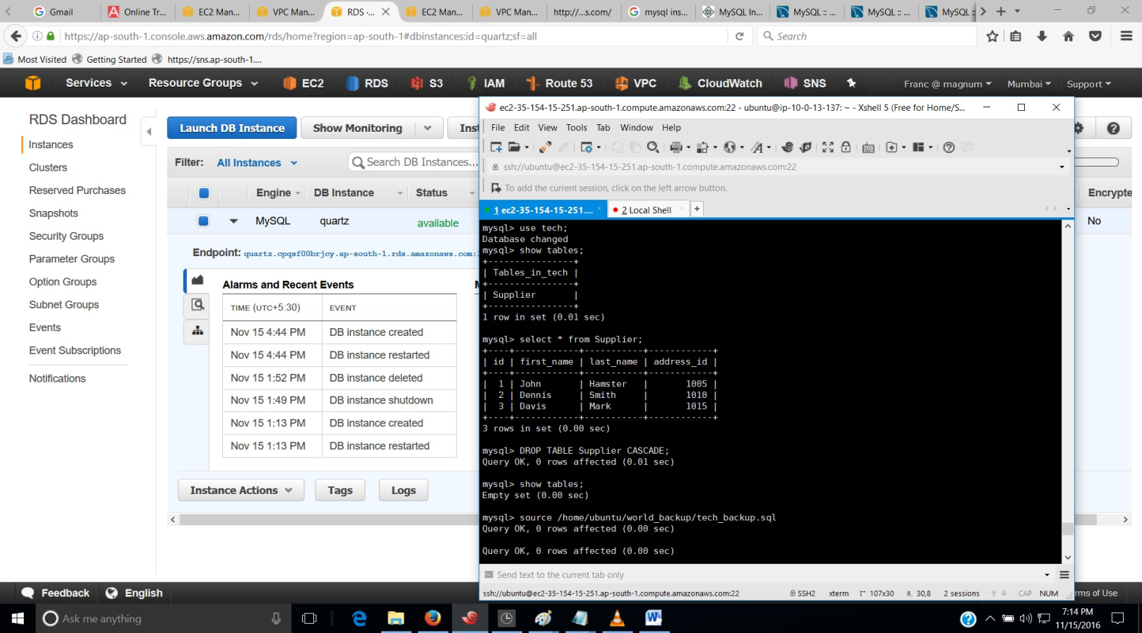

1. Verify the database and table with following commands:-

show tables;

select * from <tablename>;







